Project Design Phase-II
Technology Stack (Architecture & Stack)

Date | 24 June 2025
Team ID | LTVIP2025TMID21049
Project Name | Flight finder-navigating your air travel options
Maximum Marks | 4 Marks

Technical Architecture:
The Deliverable shall include the architectural diagram as below and the information as per the table1 & table 2
Example: Order processing during pandemics for offline mode
Reference: https://developer.ibm.com/patterns/ai-powered-backend-system-for-order-processing-during-pandemics/

Guidelines:
Include all the processes (As an application logic /
Technology Block)
Provide infrastructural demarcation (Local / Cloud) Indicate external interfaces (third party API’s etc.) -1 : Components & Technologies:
Indicate Data Storage components / services Indicate interface to machine learning models (if applicable)
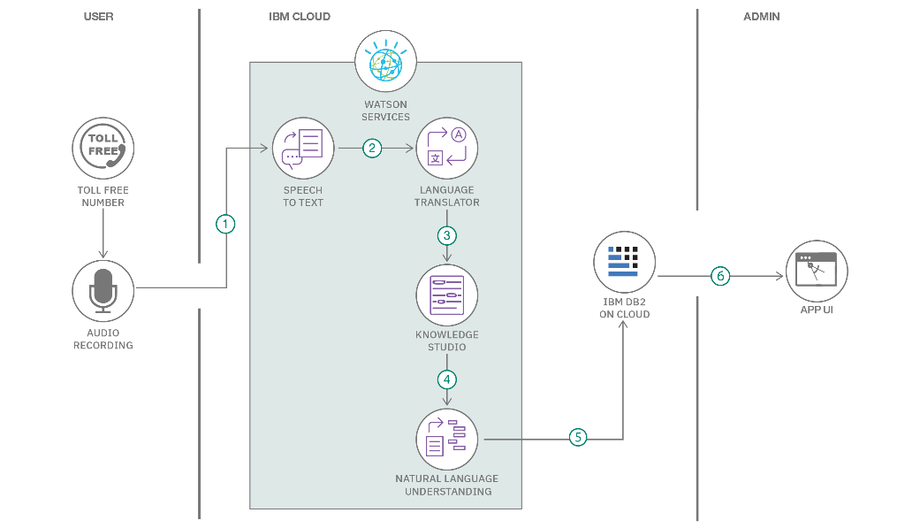
Table
S.No | Component | Description | Technology
1. | User Interface | Web interface to search and book flights | HTML, CSS, JavaScript / Angular Js / React Js etc.
2. | Application Logic-1 | Backend logic for login, registration, booking, etc. | Java / Python
3. | Application Logic-2 | model loading and prediction for flight price suggestions | IBM Watson STT service
4. | Application Logic-3 | Authentication & session management | IBM Watson Assistant
5. | Database | Store user data, flight data, and bookings | MySQL, etc.
6. | Cloud Database | Optional cloud-based backup or live data | IBM DB2, IBM Cloudant etc.
7. | File Storage | Local storage for CSV/Excel flight datasets | IBM Block Storage or Other Storage Service or Local Filesystem
8. | External API-1 | Flight data APIs (if integrated live) | IBM Weather API, etc.
9. | External API-2 | Email confirmation service | Aadhar API, etc.
10. | Machine Learning Model | predict flight pricing or recommend best options | Object Recognition Model, etc.
11. | Infrastructure (Server / Cloud) | Hosting the app for public access | Local, Cloud Foundry, Kubernetes, etc.
S.No | Characteristics | Description | Technology
1. | Open-Source Frameworks | Use of open-source tools & libraries | Flask, Pandas, Scikit-learn, Bootstrap
2. | Security Implementations | Secure login, password hashing, email verification | bcrypt, JWT, HTTPS, Flask-Login, Gmail OAuth
3. | Scalable Architecture | Modular codebase, separation of frontend/backend, scalable DB | 3-tier architecture, Microservices used
4. | Availability | High availability via cloud hosting | Load balancing (Render, Heroku Dynos, etc.)

Table-2: Application Characteristics:
S.No | Characteristics | Description | Technology
5. | Performance | Efficient queries, ML model caching, optimized routing | MongoDB indexing, Python caching, CDN (optional)

References:
https://c4model.com/ https://developer.ibm.com/patterns/online-order-processing-system-during-pandemic/ https://www.ibm.com/cloud/architecture https://aws.amazon.com/architecture https://medium.com/the-internal-startup/how-to-draw-useful-technical-architecture-diagrams-2d20c9fda90d

